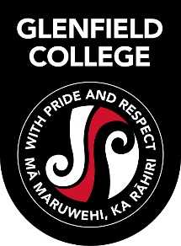

Year 13 Dress Code

Although Year 13 students at Glenfield College (2017) will not be wearing a uniform, they are expected to be role models for younger students and are identifiable as members of our school. They are expected to display our values of pride and respect at all times.

- Students should be neatly groomed at all times, males are to be clean-shaven.
- All garments are to cover the front, top, back, shoulders and midriff of the student.
- Male students are to wear collared shirts, not T shirts.
- No hoodies (except 2017 leavers’ hoodies) may be worn.
- Students may not wear thin strapped tops or tank tops, with low cut armholes or deep necklines and hems of any garment should not be higher than mid-thigh.
- No torn, ripped or frayed clothing to be worn. No beachwear, gymwear or sportswear.
- Caps only may be worn – no beanies or other headwear.
- General rules regarding appearance re: make up, jewellery etc as applicable to Years 9 to 12 students still apply to Year 13 students wearing Dress Code.
- Year 13 students may continue to wear school uniform if they wish.
- Students may not wear jandals, slippers or any other inappropriate footwear.
- The Principal’s judgement will be final where a dispute over dress code might arise.

